TC-PM-014
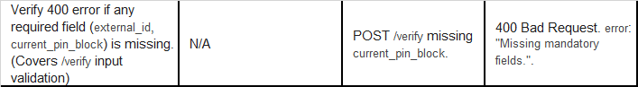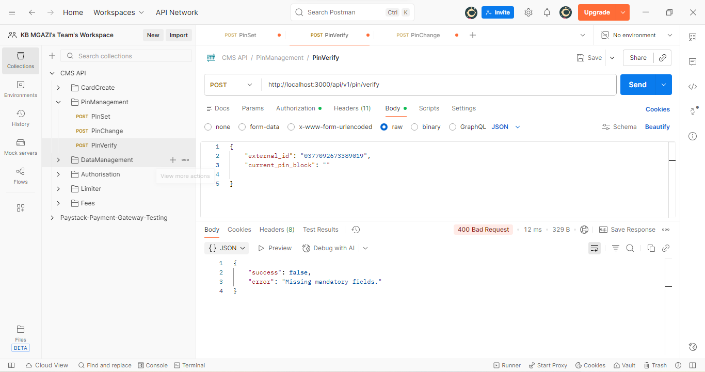
Request:
{
"external_id": "0377092673389019",
"current_pin_block": ""

}
Response:
{
"success": false,
"error": "Missing mandatory fields."
}

